Script
A new friend
Chad: Tom, are you sure the shelter's open?
Tom: Sure! Dad's friend works there every day and he says she can help us for our school project... Good morning, are you Linda? I'm Tom Spencer. This is my friend Chad and Zoe is my little sister. Can we ask you some questions?
Linda: Of course! Children are always welcome here!
Tom: Cool! What do you do exactly? Linda: Well, every day I take care of the animals in the shelter, I feed them, brush them...
Chad:... Wow! It's very noisy in here! What sort of animals are there? Linda: There are a lot of dogs and cats, some hamsters and some guinea-pigs...
Zoe: Are there any snakes? Tom: Oh you silly girl!
Linda: No, there are no snakes here.
Alfie: Welcooome... Aaalfiiie's huuungrrry!
Zoe: Oh, it can talk!
Linda: This is Alfie the parrot. He's very talkative. He always keeps me company here. We often have lunch together. He's very greedy.
Zoe: What does he eat?
Linda: He usually eats biscuits, seeds and sometimes fruit too but he doesn't eat any meat.
Alfie: Aaalfiiie neveeer eeeeatssss meeaat! Linda: Luckily he sleeps about 10 hours a day!
Zoe: Oh, he's got a beautiful black coat. He's so cute!
Linda: This is Chester. He's very friendly. Tom: Why is he barking? Does he often bark at people?
Linda: Yes, always when he's happy. Tom: See, he's very energetic! Do you often take him to the park?
Linda: No, I don't. Volunteers take him to the park three times a week.
Chad: Oops! He's very big too. Nooooo, Chester!
Linda: Don't panic! He is never aggressive. He loves children. He just wants to lick your face!
Chad: Yuck! That's disgusting! Tom: Well, I think you've got a new friend!

- EXPLANATION OF THE KEYWORDS

- Shelter = Abri
- Take care of = Prendre soin de…
- Noisy = Bruyant
- Dogs = Des chiens
- Cats = Des chats
- Guinea-pigs = Des cochons d’inde
Snakes = Des serpents
- Parrot = Perroquet
- Friendly = Aimable
- To bark = Aboyer
- Talkative = Bavard
- Luckily = Heureusement

- WORDS TO REMEMBER
- Volunteer
- Agressive
- Cute
- Ugly
- Usualy
- Brush
- Feed
- Keep somebody company
- To lick , To feed
Ps : Surdents must do researches to find out the French meanings of the words above.
- GRAMMAR :
- THE PRESENT SIMPLE AND THE EXPRESSION OF FREQUENCY.
→You use adverbs of frequency and the present simple to say if you do an action always (toujours), usually (habituellement), often (souvent), sometimes (parfois), or never (jamais).
The adverb of frequency always comes before the verb. But it is placed after the auxiliary be.
Affirmative form | Negative form | Interrogative form
Chester is always energetic | My cat doesn’t often eat carrots. | How often do you feed her ?

- SOME, ANY and NO.
You use some, any, and no to express a certain amount or lack of something.
Ex1 : There are some puppies in the shelter. (= I'm sure there are)
Ex2 : There are no snakes. There aren't any snakes. (= I'm sure there isn't)
Ex3 : Are there any rabbits? (= I'm not sure)
You also use some in questions when you know something exists and want to ask permission to take it.
Ex : Can I have some milk, please?

KEYWORDS ANNEX.

  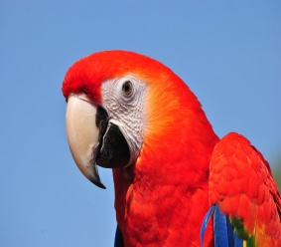
A CAT. A DOG. A GUINEA-PIG. A PARROT.
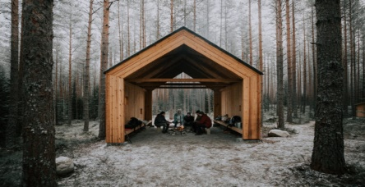
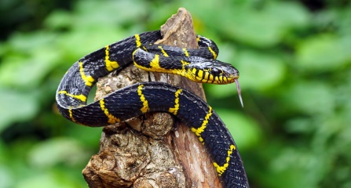
A SHELTER. A SNAKE.
Exercise 1
Conjugate the verbs in parentheses in the present simple. Pay attention to the place of the adverb.
- Chester (run) in the garden. (always)
- I (not take) my cat to the park.
- My hamster (sleep) at night. (never)
- Linda (brush) the animals at the shelter. (sometimes)
- Parrots (not eat) meat. (usually)

Exercise 2

Match the questions (a-d) to the answers (1-4).

Questions
- How often does he walk your dog?
- What do you do at the shelter?
- Do you sometimes brush your guinea-pig?
- What is your monkey like?
Answers
- I usually help with the animals.
- Yes, sometimes.
- He's always funny and clever.
- He walks him twice a week.
Execise 3
Complete with some, any or no.
- Are there .........pandas in the shelter? No, there aren't........
- Can I have..........tea? Sorry there isn't..........
- There are..........rabbits in the shelter but there are........snakes.

